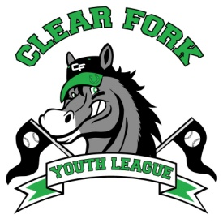
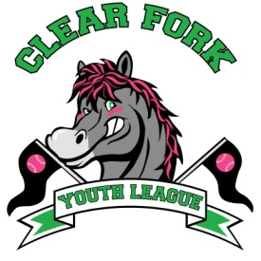
BOARD MEETING
FEBRUARY 13, 2019
Attendance:
Jay Vail
Mike Hoeflich
Josh Smith
Allen Leech
Ashley Ludwig
David Myers
Lindsay Roberts
Craig Smith
Clint Knight

- Clint
  - Gave details on 5K
    - We would need insurance, a running route, possible sponsors and would have to start advertising in March
  - The board will need to decide if the 5K is something we would like to continue looking into
- Josh
  - Middle school softball update
    - Will run the same as last year and restructure the program for the following season
- Jay
  - Discussion on current field maintenance and possible ways to save money and improve for the upcoming season
  - Will have a field day April 14 @ 1:00
- Allen
  - Dick’s Sporting Goods donated approximately $1500 worth of equipment to baseball, softball and soccer programs along with 20% coupons, the more coupons that are used the larger their donation to us next year. Our shopping day is March 30th
  - Bank Account looks good
  - Asked the board to consider putting any funds made from Bingo into the Core bank account
- David
  - Taking inventory and will make a final list for an equipment order
- Ashley
  - Ronda Gearhart is asking to make order forms for baseball/softball shirts for our coaches to hand out. Adult shirts will see for $25, youth for $20, she will donate $5 for each sale back to the youth league
    - Board voted yes
- Next Board Meeting March 13, 2019 7:00 @ Brumby’s

